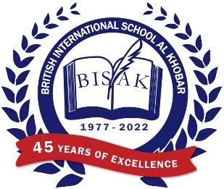



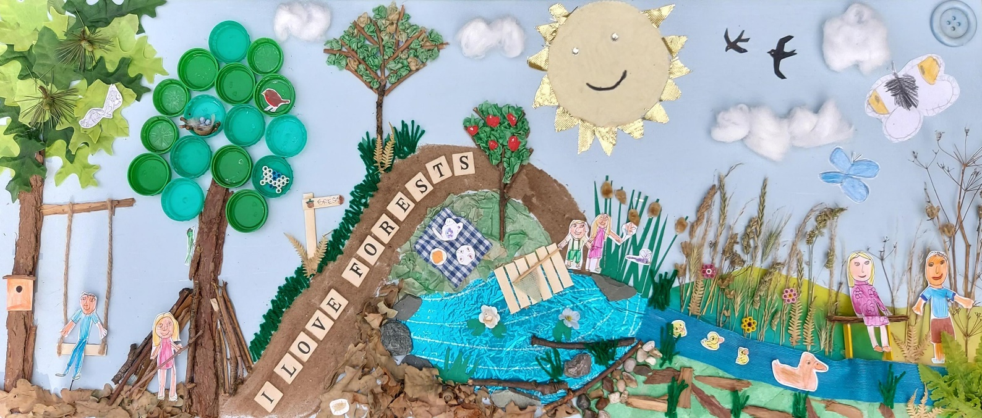

We are inviting students to produce a piece of art that reflects this year’s competition theme **‘A Future to Be Proud Of'**.

**Judging Criteria**

The competition judges will be scoring the entries according to the following criteria:

* Imagination and originality
* Overall impact of the finished piece
* Technical challenges and use of material
* Sticking to the brief: ‘A Future to Be Proud Of’.

**How to Enter**

**Preparatory School** (EYFS - Year 6), please submit a **clear** photograph of your entry and a description of the artwork via email to mariacarlin@bisak.org on or before **Tuesday 7th November 3pm 2023.** Please include your full name and class in the email.

**Senior School** (Year 7 – Year 13), please submit a clear photograph of your entry and a description of the artwork via email to EdelO’Kane@bisak.org on or before **Tuesday 7th November 3pm 2023.** Please include your full name and class in the email.

Please keep your original Artwork safe at home in case you are the winner of the category as we will need to send it to COBIS.

BISAK can submit ONE entry **per category to COBIS.**

* EYFS and Key Stage 1
* Key Stage 2
* Key Stage 3
* Key Stage 4
* Key Stage 5

**Materials**

You can use any materials you wish, for example, paint, collage, mixed media, recycled materials, clay, cardboard, ink, Modroc etc. Your artwork can be 2D or 3D.

**COBIS Winners and Prizes**

A certificate and prize from COBIS will be awarded to the winner and runner-up of each category.

**Winner:** £50 Amazon voucher plus an AUB tote bag with art materials*  
**Runner-up:** £25 Amazon voucher plus an AUB tote bag and sketch book*

*The KS4 and KS5 winners and runner-up will also win AUB tote bags and an AUB creative workshop or webinar for their whole class (topics to be confirmed).

**BISAK Winners**

One winner from each of the categories above will be selected by the Art department to represent BISAK at the COBIS finals. The winners chosen by our Art department will also receive 25 BISAK points, a certificate and art supplies.